PhD Viva Voce
Candidate Name: | John Siayi | 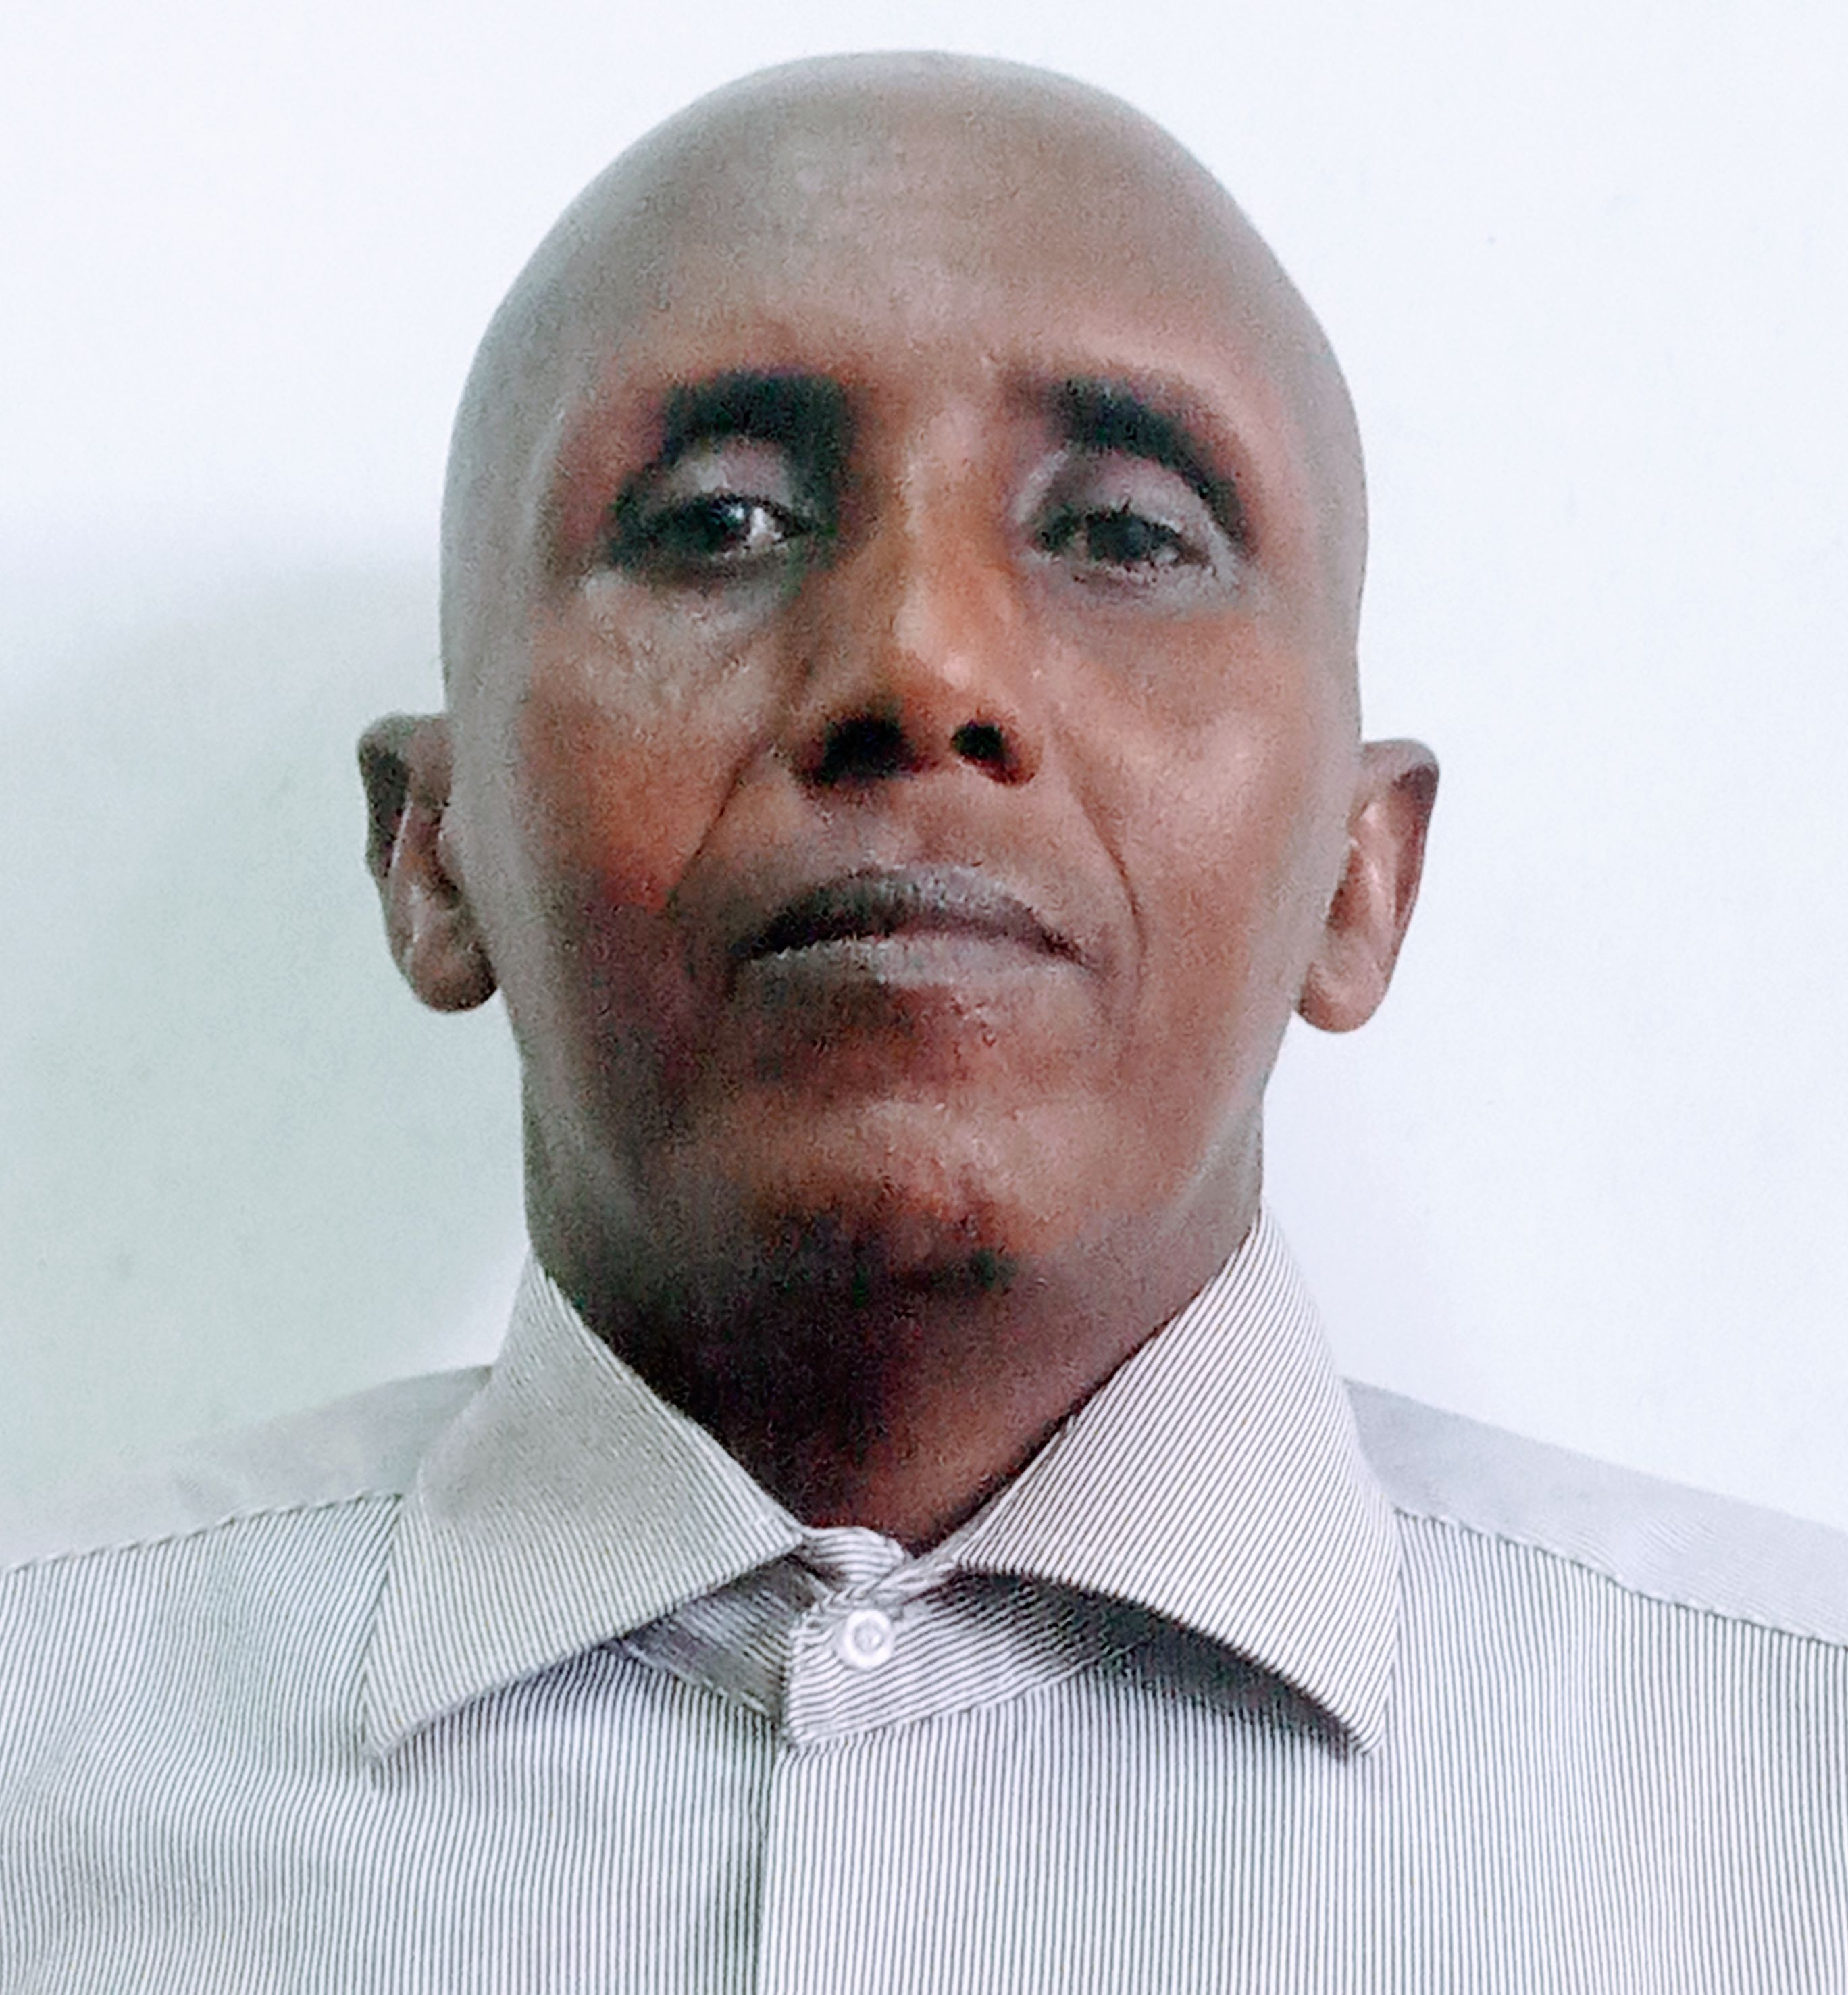
Registration Number: | 2017-07-00169
 | University of Dar es Salaam
 | School of Education

Qualifications Attained:
Mr. John Siayi is a PhD candidate (by Coursework and Dissertation) in the Department of Physical Education and Sport sciences at School of Education, University of Dar es salaam. He holds Master degree (Master of Arts in Education) and Bachelor degree (Bachelor of Education in Physical Education, sports and culture) from University of Dar es salaam. Currently, he is an Assistant Lecturer in Physical education, Track and Field athletics, Racket games (Table and Table tennis) and Motor learning and performance in the Department of Physical Education and Sport Sciences, University of Dar es salaam. As a researcher, his areas of interest are exploring issues in Physical activity, Physical Education pedagogy, Track and Field athletics Development and Racket Game Development. His other research area is Research methods in Physical Education and sports.

Title of Thesis: | Examination of Teachers’ Pedagogical Content Knowledge, Beliefs and Practices in Teaching Physical Education in Tanzanian Secondary Schools
Date of Viva Voce: | 22nd February, 2024
Venue: | Board Room-SoED
Time: | 10: 00a.m
Supervisors: | Dr. Stephen Mabagala & Ismail N. Pangani

Abstract:
The purpose of this study was to examine how pedagogical content knowledge and beliefs of physical education (PE) teachers in Tanzanian secondary schools affect pedagogical practices in teaching PE. The three objectives of this study were to establish the pedagogical beliefs that PE teachers hold in teaching PE in secondary schools, to examine the use of PE teachers’ pedagogical content knowledge in teaching PE in secondary schools, and to assess teachers’ pedagogical practices in teaching PE in secondary schools. The study employed social constructivism research paradigm, qualitative research approach and descriptive case study design. Purposive sampling technique was used to select eight PE teachers from Dar es Salaam and Ruvuma regions. Interview, classroom observation and documentary reviews were used to collect data. Findings reveal that PE teachers believe on learner-centred teaching approach theoretically. They also believe on discussion teaching method, summative assessment, teaching PE class with fast learners. Moreover, findings indicate that PE teachers had inadequate pedagogical content knowledge in teaching PE. It was found out that teachers had inadequate knowledge on linking teachers’ activities with learners’ activities and assessment tasks. It was further revealed that teachers had limited knowledge of classroom management. The majority of teachers had adequate content knowledge but was directly confined to practical skills. It was disclosed that teachers were aware of the importance of the community with which they were working and parents’ socioeconomic status but they confined parents’ facilitation on students’ learning to parents’ power to purchase sports gear for their children. Furthermore, findings revealed that PE teachers practically used teacher-centred teaching approach in teaching PE where lecture method dominated in the classrooms. Lesson preparations were inadequate, as some schemes of work lacked some sub-content, main objectives lacked specific tasks and lesson plan documents were prepared occasionally. Teachers used oral questions as assessment and classroom management tool where most of the questions were limited to lower order of thinking. Teachers conducted classroom assessment inadequately as assessments at each stage of the lesson development were skipped in most of the PE lessons. Additionally, the teacher with whole class interactions dominated in most other classrooms. It was concluded that teachers’ beliefs and pedagogical content knowledge about teaching PE were largely antithetical to principles and practices of learner-centred pedagogy. It is recommended that PE teachers should adopt learner-centred teaching approaches and its corresponding teaching methods practically. Teachers should be exposed to in-service seminars and workshops regarding the use of pedagogical content knowledge in classrooms.
Panel Members
No | Name | Designation | Rank | Unit
 | Prof. Abel Ishumi | Chairperson | Professor Emeritus | SoED-EFMLL
 | Dr. Joyce Ndabi | Representing External Examiner | Lecturer | SoED-PESS
 | Dr. Jonas Tiboroha | Internal Examiner | Lecturer | SoED-PESS
 | Dr. Stephen Mabagala | Candidate’s Supervisor | S/Lecturer | SoED-PESS
 | Dr. Cyprian Maro | Head of the relevant department (or his/her appointee) | S/Lecturer | SoED-PESS
 | Dr. Albert Tarmo | Co-opted Member (appointed by College/School/Institute | S/Lecturer | SoED-EPCS
 | Dr. Septimi Kitta | Co-opted Member (appointed by College/School/Institute | S/Lecturer | SoED-EPCS
 | Dr. Hezron Onditi | Appointee of the Principal for PhD only) | S/Lecturer | DUCE-EPCS

